**Spring Boot Starters**

**Spring Boot Starters**:

Starters are a set of convenient dependency descriptors that you can include in your application. You get a one-stop shop for all the Spring and related technologies that you need without having to hunt through sample code and copy-paste loads of dependency descriptors. For example, if you want to get started using Spring and JPA for database access, include the "**spring-boot-starter-data-jpa**" dependency in your project.

The starters contain a lot of the dependencies that you need to get a project up and running quickly and with a consistent, supported set of managed transitive dependencies.

* A curated list of Maven dependencies
* A collection of dependencies grouped together
* Tested and verified by the Spring Development team
* Makes it much easier for the developer to get started with Spring
* Reduces the amount of Maven configuration

**Example**:

There are 46+ Spring Boot Starters from the Spring Development team

|  |  |
| --- | --- |
| Name | Description |
| spring-boot-starter-web | Starter for building web, including RESTful, applications using Spring MVC. Uses Tomcat as the default embedded container |
| spring-boot-starter-web-services | Starter for using Spring Web Services |
| spring-boot-starter-security | Starter for using Spring Security |
| spring-boot-starter-websocket | Starter for building WebSocket applications using Spring Framework’s WebSocket support |
| spring-boot-starter-oauth2-client | Starter for using Spring Security’s OAuth2/OpenID Connect client features |
| spring-boot-starter-data-rest  …… | Starter for exposing Spring Data repositories over REST using Spring Data REST  …… |

**For details**: <https://docs.spring.io/spring-boot/docs/current/reference/htmlsingle/#using-boot-starter>

**Dependency management / View feature**:

Most IDEs has a dependency management or view feature. This is much easier to navigate. Here we will see the dependency management or view feature by using "Eclipse".

Go to **pom.xml -> Dependencies** Expand the desired starter.

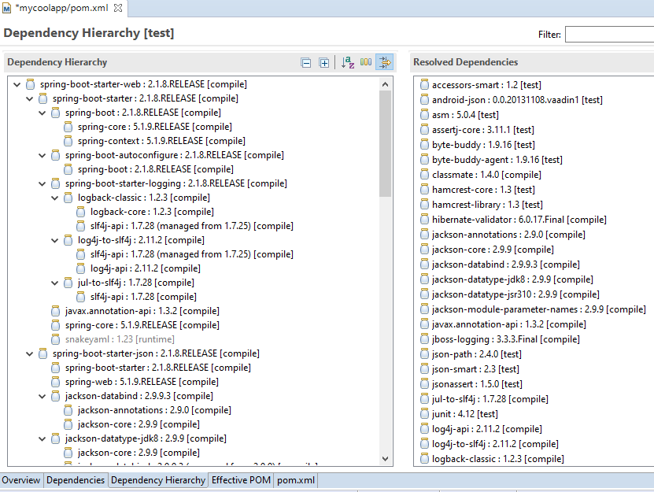

**Spring Boot Starter Parent**:

The spring-boot-starter-parent dependency is the parent POM providing dependency and plugin management for Spring Boot-based applications.

<parent>

<groupId>org.springframework. </groupId>

<artifactId>spring-boot-starter-parent</artifactId>

<version>2.1.8.RELEASE</version>

<relativePath /> <!-- lookup parent from repository -->

</parent>

The "**spring-boot-starter-parent**" is a special starter that provides useful Maven defaults i.e. it adds all the required jars and other things automatically. It also provides a dependency-management section so that we can omit version tags for dependencies you are using in pom.xml.

For ex. suppose we want to create web application with spring boot and we need the **" spring-boot-starter-web**" dependency. So we need to add the following code in por pom.xml file.

<dependencies>

<!-- Spring Boot Starters -> A collection of Maven dependencies (Compatible

versions) -->

<dependency>

<groupId>org.springframework.boot</groupId>

<artifactId>spring-boot-starter-web</artifactId>

</dependency>

</dependencies>

Now note here that "**version**" tag is omitted. So ultimately the "spring-boot-starter-parent" adds so many things by default so we no need to worry about those things.

---END---